**Practical 4**

**AIM** : Create and Simulate a Simple Adhoc Network

Take 2 wireless router 3 PC and 3 Laptops

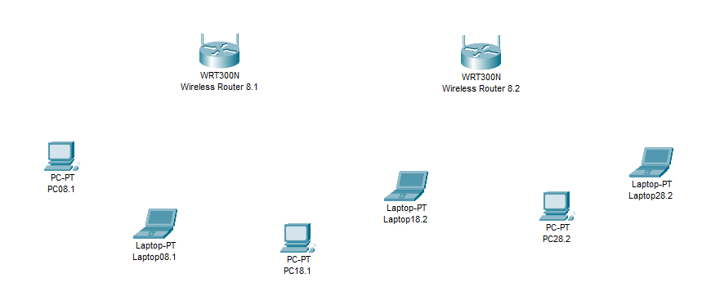

Click on any router and go to the GUI section

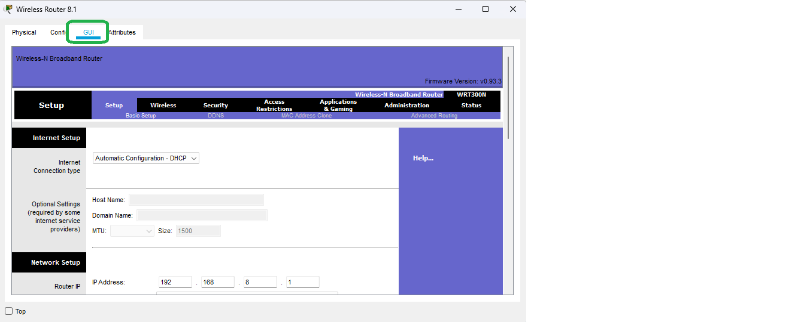

Go to the basic **Wireless** setting section and name the router according to your choice and then click on save settings

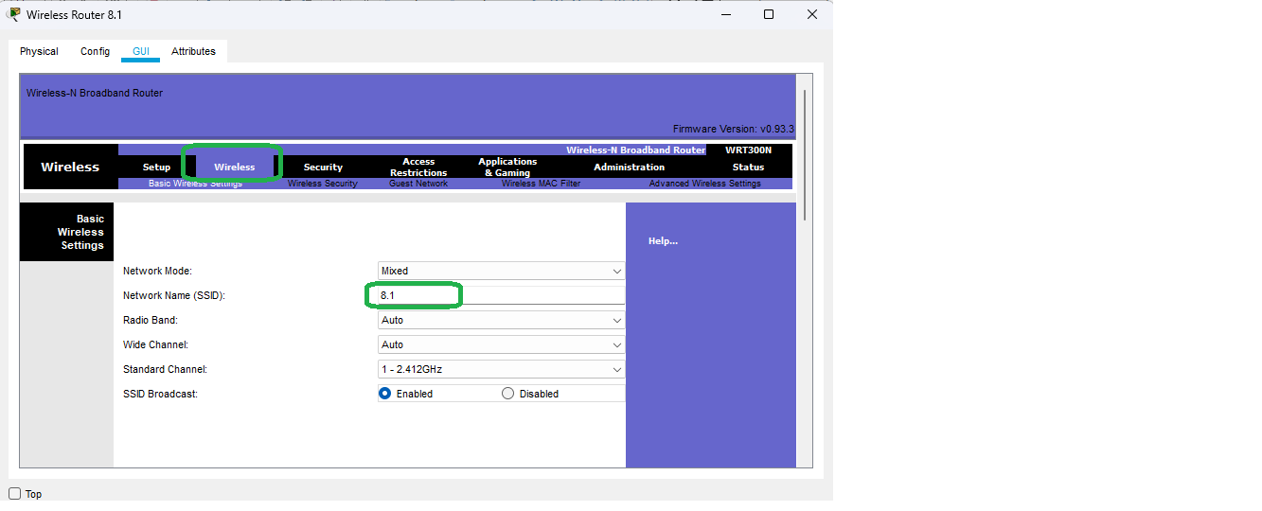

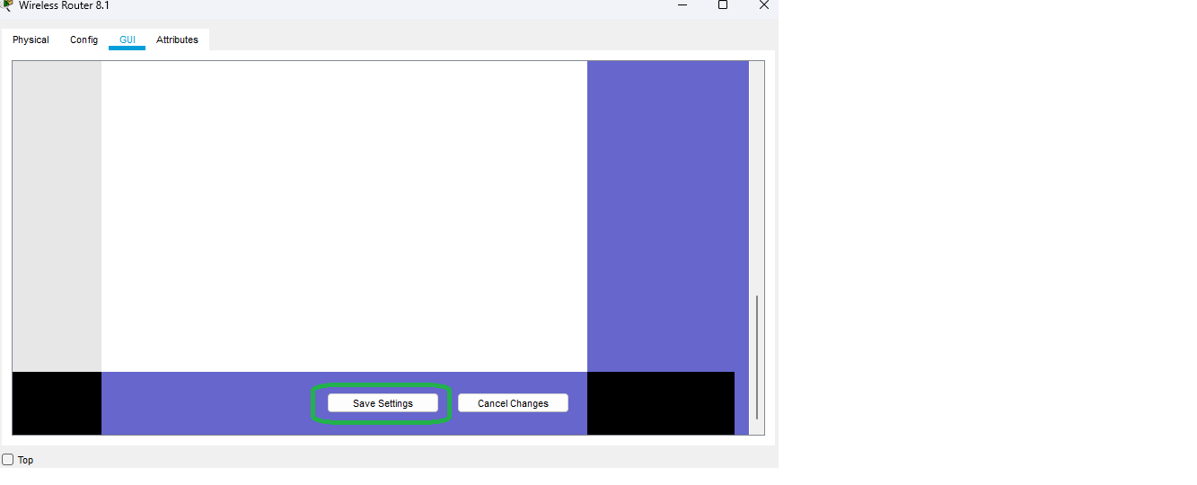

Then go to **Wireless Security** and set the password for the router and click on save settings.

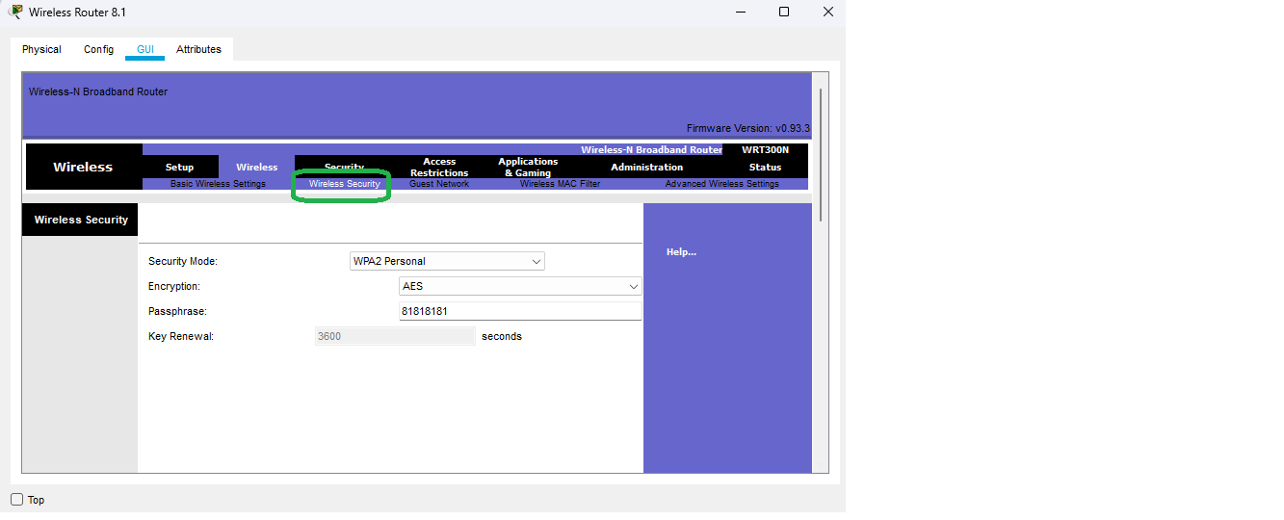



Then go to **Administration tab** and **Enable** the **Remote Management** and then click on save settings

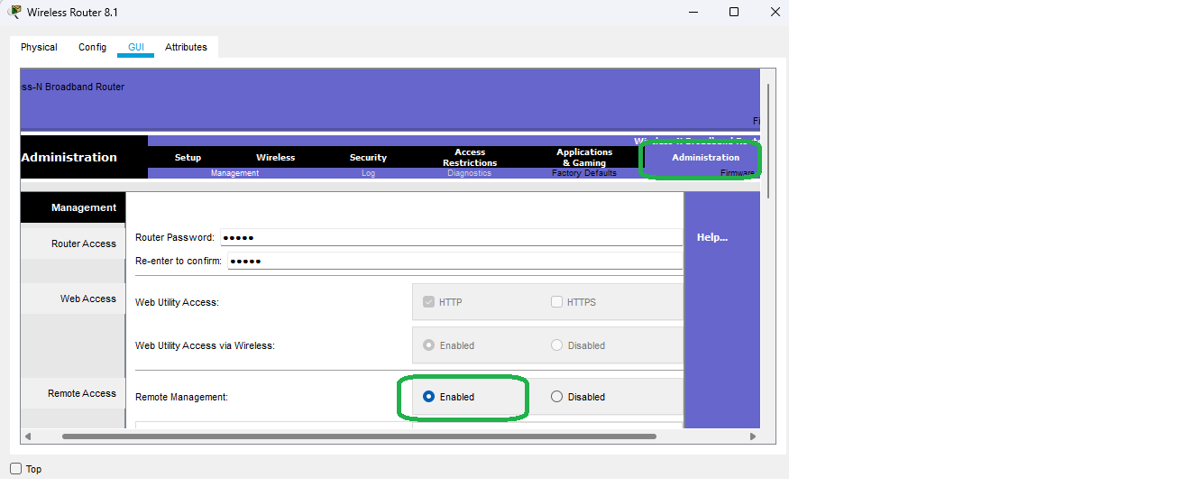



Do the same for the second router

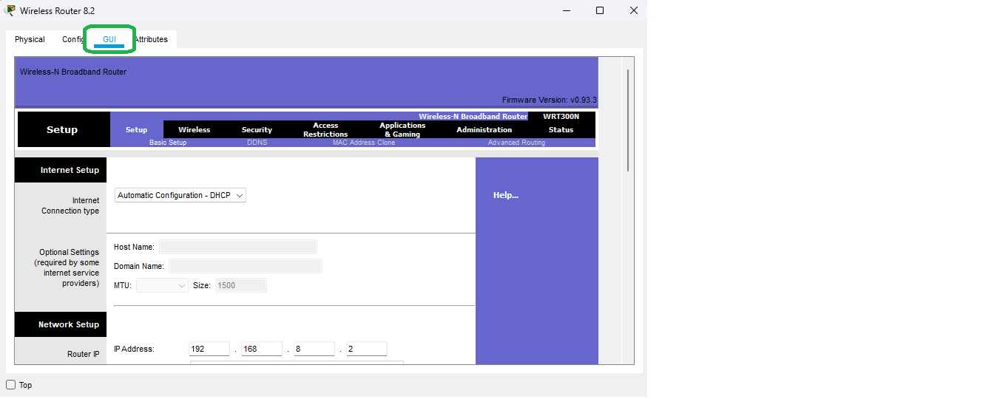

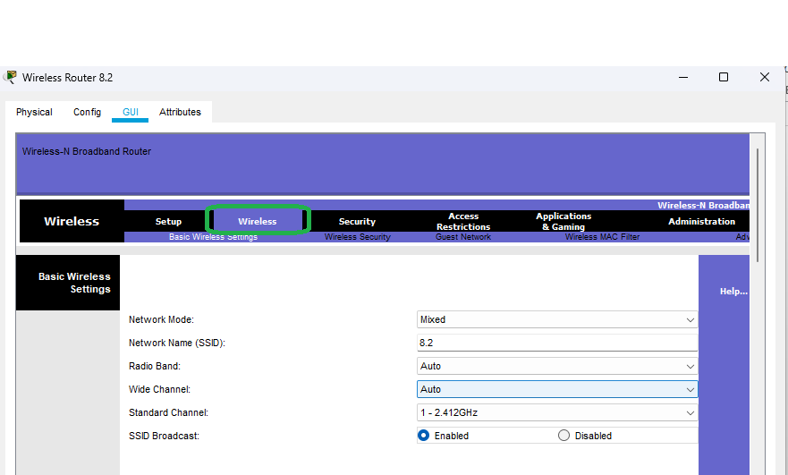

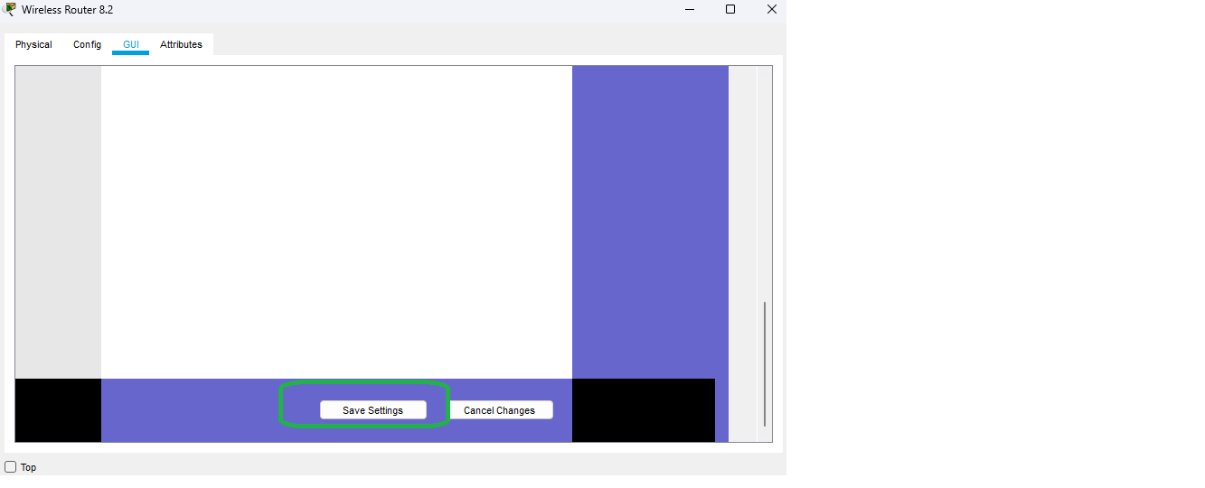

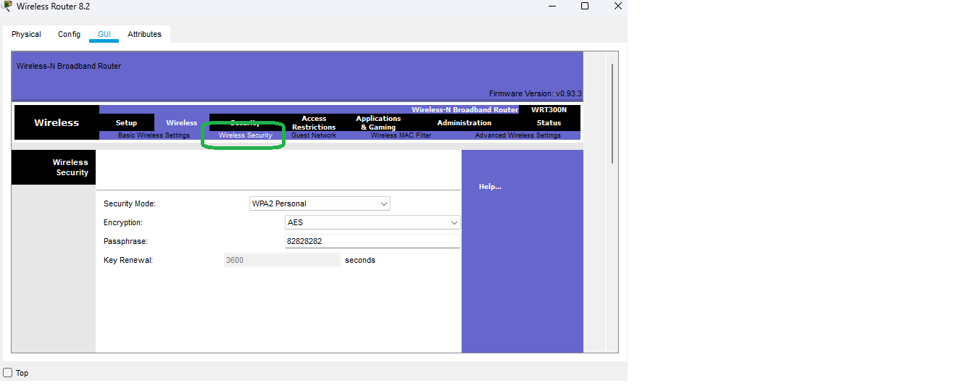



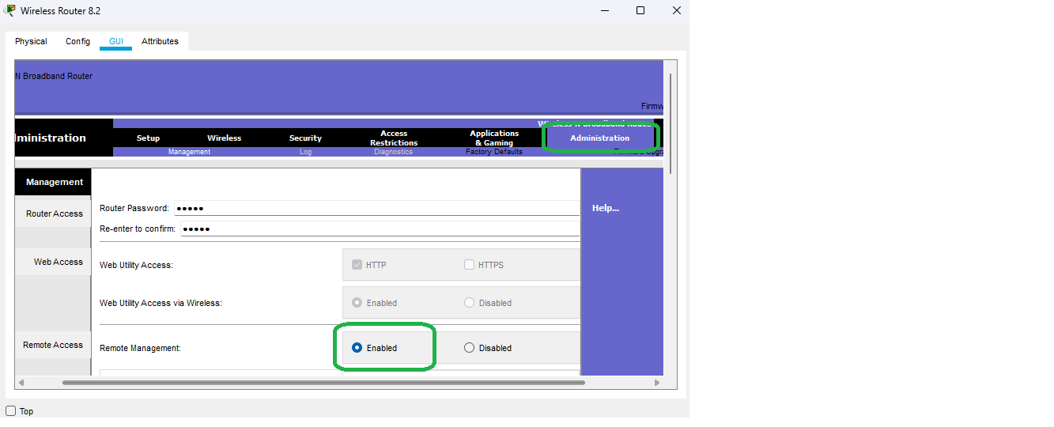



Now we connect the two routers with each other using the **Copper-Cross Over Wire**

 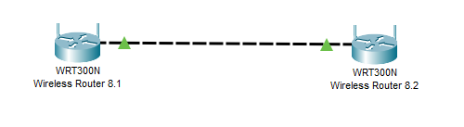

Now we insert the **WMP300N** module in all the pc and laptop one after the other

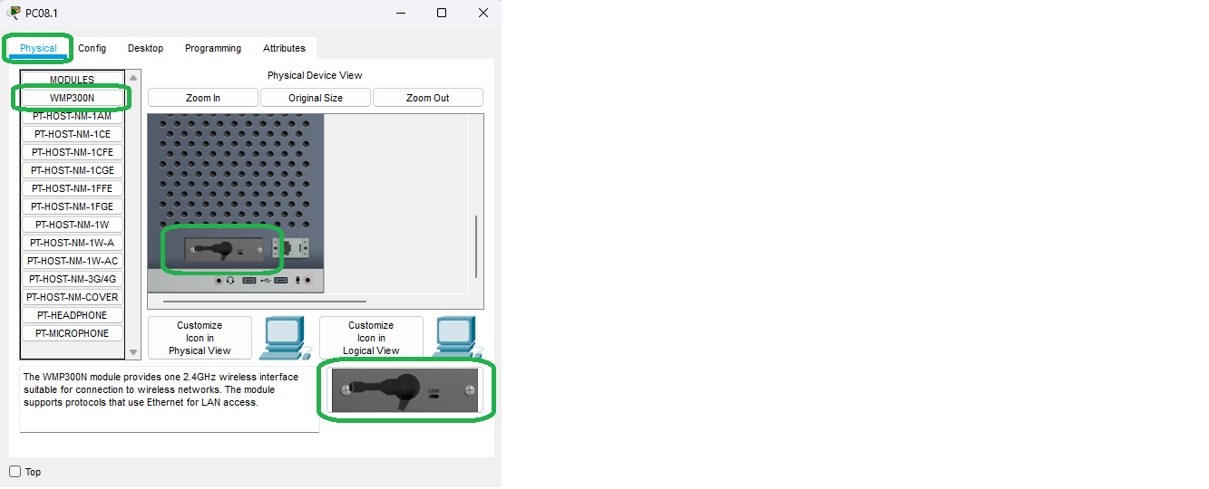 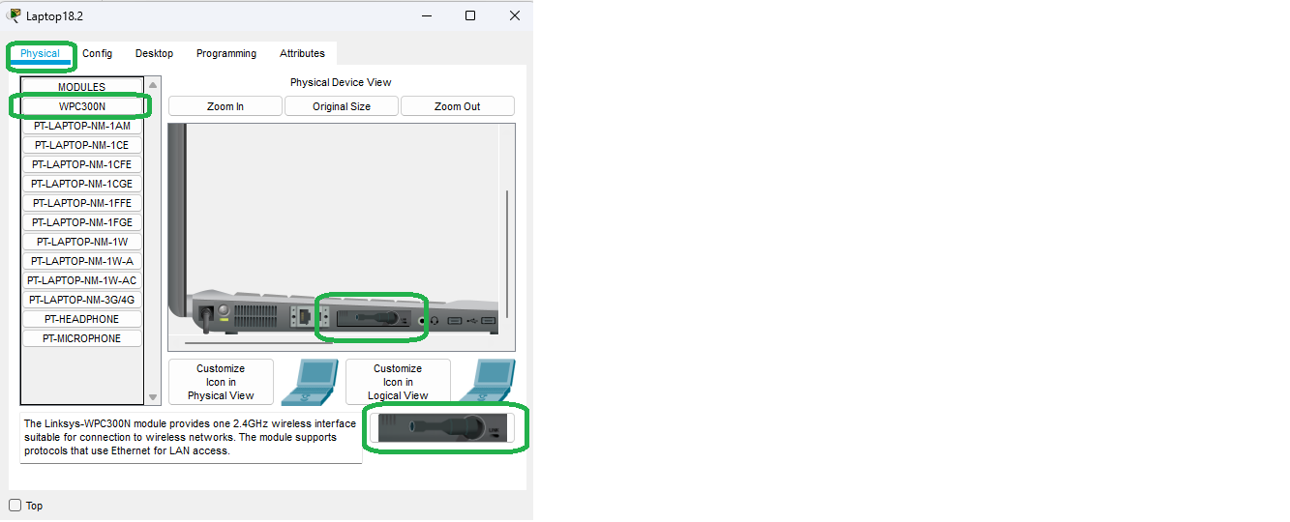

Then we connect the pc to the router by going to the **PC Wireless** in the **Desktop**

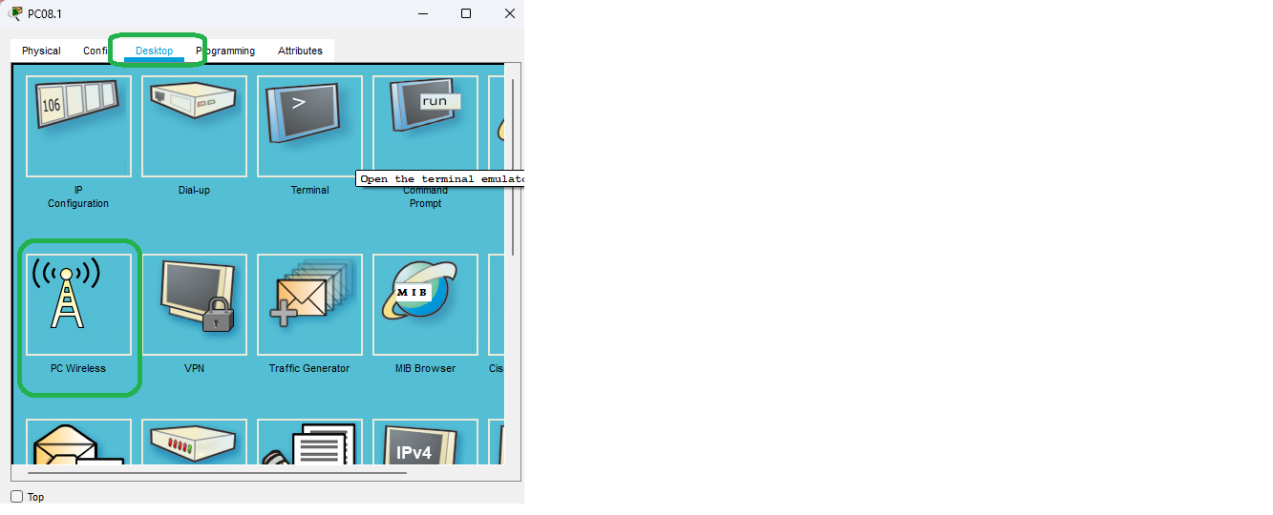 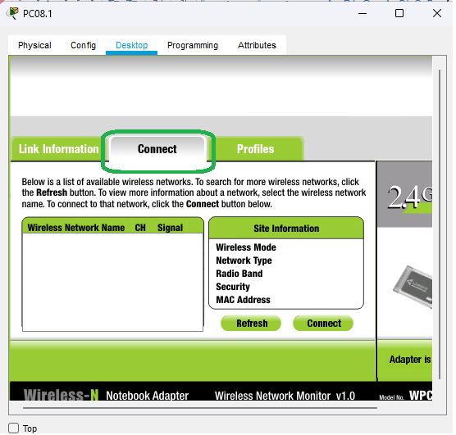

Then click on refresh and then we can see the routers which were configured

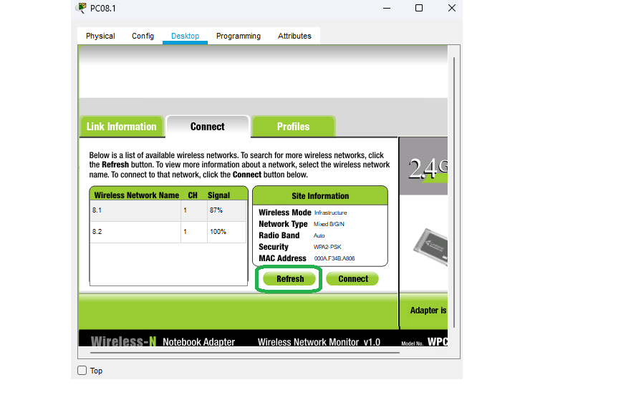

Click on any router and then click on connect and then enter the password

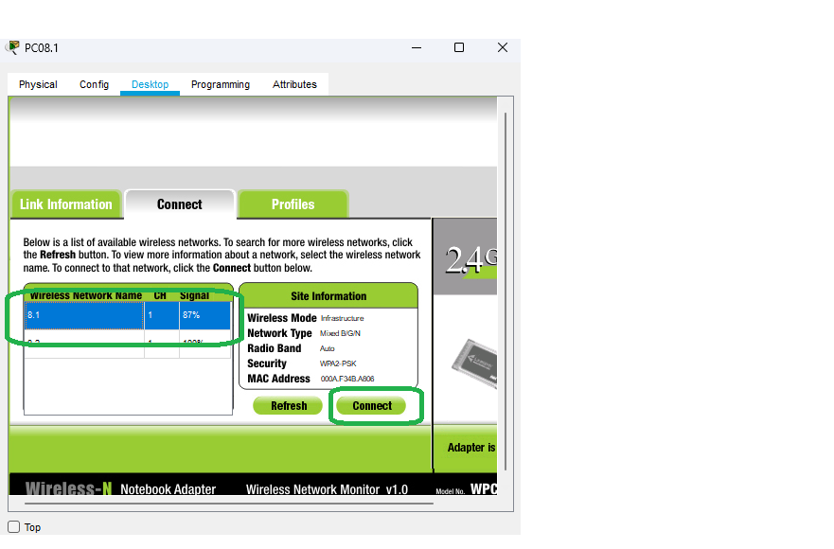 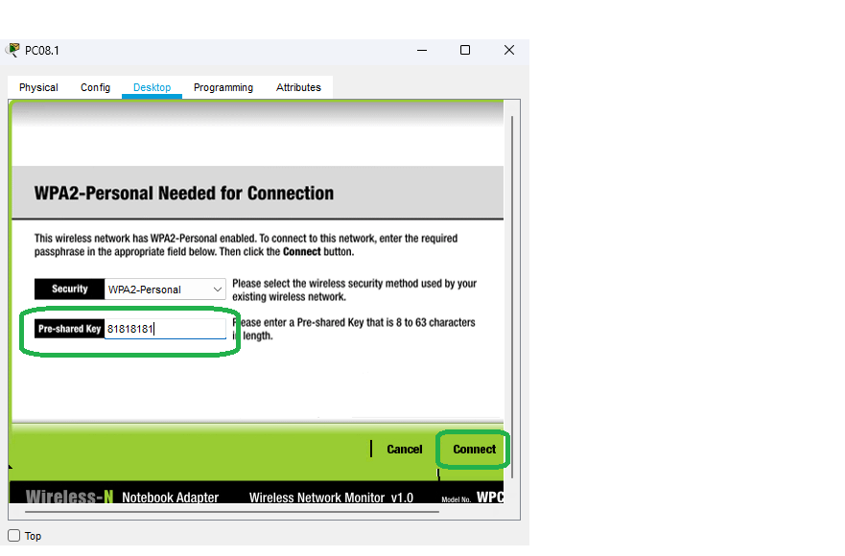

We have successfully connected all the devices to the router

